EMERGENCY PROCEDURE PLAN
2026
BONSALL PARISH COUNCIL

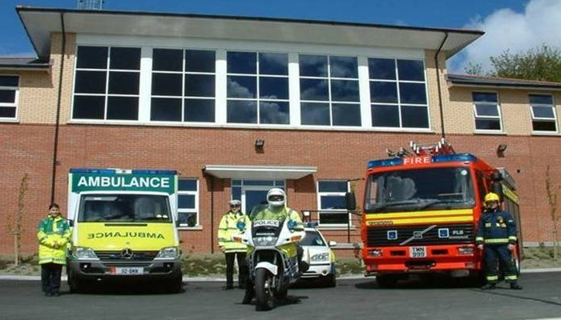
Call 999 if there is a risk to life

Plan to be reviewed April 2027

Parish Council Community Emergency Co-ordinators
Name | Contact Details
Jackie Smith - Clerk | 07771 764366 – 49 Church Street
Mark Harris - Chair | 07808 097040
Richard Grover – Vice Chair | 07305 075392
Steve Smith – Councillor | 07545 062413
Jon Barry - Councillor | 07866 750636
Andrew Spowart - Councillor | 07494 687712
Connor Binns - Councillor | 07718 953420

It is important to note that people should not put themselves or others at risk. This plan is to assist in the case of an emergency.
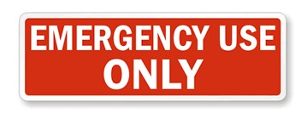

If you are in immediate danger, call 999


INTRODUCTION
BONSALL EMERGENCY PROCEDURE PLAN 2026

'By becoming more resilient, you and your community can complement the work of local emergency responders and reduce the impact of an emergency on your community both in the short and long term.' (www.gov.uk)
This is a plan to assist with a major incident which may occur in the future, such as a flooding incident or an epidemic such as the recent COVID outbreak.
In the event of a major incident in or near the parish, Bonsall’s Community Emergency Co-ordinators will activate the Plan after contacting the appropriate authorities:
Objectives of the Emergency Procedure Plan:
- To establish a community emergency co-ordinators' team that will coordinate the community response and liaise with the emergency services / local authorities as appropriate.

- To identify actions required to minimise the harm from identified hazards or threats.

- To establish a means of identifying vulnerable people in the community with a view to supporting them in an emergency.

- To identify resources in the community that would be available to minimise the severity of the emergency.

- To establish key contact details for the emergency services and local authorities, the Local Community Emergency Co-ordinators and key community resources.

USEFUL TELEPHONE NUMBERS

POLICE/AMBULANCE/FIRE SERVICE 999

Gas Leaks |  | 0800 111999
Severn Trent |  | 0800 7834444
Environment Agency |  | 0800 80 70 60
Electricity Emergencies |  | 0800 0568090
Defibrillator Co-Ordinator  First Aid | Richard Taylor | 823704  07860 214503
Floodline (24 hrs) |  | 0345 9881188
This is a live list and will be added to when further details of useful telephone numbers are obtained

FIRST STEPS IN AN EMERGENCY - PLAN ACTIVATION TRIGGER
If you become aware of a serious incident happening or threatening to develop, call the emergency services on 999 giving your name, contact details and details of the incident. Do not put yourself at risk. Contact the Emergency Co-Ordinators
POSSIBLE LOCAL RISKS
Hazard | Location | Effect | Consequences | Mitigation of impact prior to incident | Mitigation of impact post incident
Flooding | Roads/properties in the village | Vehicular Access plus access to properties | Flooding of several properties and roads | Distribute flood sacks  Assist vulnerable residents to safeguard their properties  Ensure resident safety by keeping vulnerable people indoors.  Updates on social media sites – Bonsall Help Group – Bonsall Flood Wardens – Bonsall FB page | Evacuate to appropriate reception centre to provide shelter, heat and hot drinks where necessary and appropriate
Heavy snow and icy conditions | Village roads and paths | RTC AND injury hazard | Unable to enter/leave village and vulnerable residents unable to leave home  May need supplies or to keep medical appointments etc. | PC to ensure grit bins are stocked.  Knowledge of vulnerable residents –check in on local vulnerable residents  Updates on social media sites as above | Coordinate visits to identified vulnerable people; organise food delivery; liaise with voluntary group; clear footpaths; keep community informed
Fire, explosion | At any property/business in the village | People  living in the immediate  vicinity | Serious injury/death  Evacuate and first aid until emergency services arrive. Fire and rescue service is responsible for identifying the inner cordon and for the health and safety of all those operating within it. Police will  co-ordinate the response |  | Follow advice from services
Hazard | Location | Effect | Consequences | Mitigation of impact prior to incident | Mitigation of impact post incident
Gales /  Storms | Entire village | Entire area | Serious injury/death from falling debris/trees | Keep indoors where possible and only drive if necessary. Avoid tree areas. Knowledge of vulnerable residents –check in on local vulnerable residents  Updates on social media sites as above  When safe to do so possible clearance of fallen trees | Follow advice from services and media/weather watch
Heat wave | Entire village | Entire area | Death/serious illness – vulnerable residents Important to keep cool and safe indoors and follow advice. | Ensure have personal resilience plans cooling fans/areas to keep cool  Social media groups as above to be used to co-ordinate checking on vulnerable residents | Follow advice from services/weather watch, government and NHS

VULNERABLE PEOPLE
It is important to ensure that isolated or vulnerable people are contacted to establish if they need assistance during an emergency.
Historically, especially during the COVID epidemic, Bonsall Parish Council and residents began a help group to assist the vulnerable residents of the village for the duration of such incidents. Those who are vulnerable are known to Councillors and neighbours and all are assisted. This is still an ongoing process.
Bonsall has in place a Flood Warden Scheme which is organised similarly to the help group and the wardens ensure that assistance is given to vulnerable residents during such times.
There is a group of residents who are defibrillator trained and there are defibrillators sited at different points throughout the village. These are maintained and upkept by the defibrillator co-ordinator and names and telephone numbers of all those trained are well publicised in the village newsletter and on notice boards.
In the unlikely event that the Emergency Procedure Plan is activated, as has occurred with previous incidents, residents would volunteer their skills, tools, resources, vehicles and machinery to assist.
EVACUATION
During an emergency, it may become necessary for some members of the community to be evacuated from their homes to a safe place.
The Bonsall Help/Flood Warden and Village Social Media pages can be utilised to assist with putting the plan into place, specifically with but not limited to:
- Visiting residents to inform them of the emergency (particularly if the telephone lines are not working)
- Help to staff a safe evacuation space
- Identify residents who need assistance
- Assist residents to move to a place of safety

PLACES OF SAFETY WITHIN THE VILLAGE IN THE CASE OF AN EMERGENCY
In the unlikely event that the Emergency Procedure Plan needs to be activated, the following premises will be utilised as a place of safety:
First Choice is Bonsall Village Hall
This is situated on The Dale, adjacent to the Fountain Tea Rooms. It has the following amenities:
- A key to the hall is always available in the key safe at the front door. The secretary of the village hall is Jackie Smith, telephone 07771 764366. All management committee members of the hall have the code to the key safe.
- Disability access is via the lift which is along the ramp at the front of the building. Instructions are provided at the lift site.
- There is Wi-Fi in the building but no telephone landline. Mobile telephones will be required.
- There is a large hall on the ground floor with 2 WC’s, one of which has disabled and nappy changing facilities. There is a large professional kitchen off the hall with fridge, cooker, microwave, kettle, urn etc. and cutlery, crockery and other kitchen items. It is a warm space with good heating. Tables and comfortable chairs are available.
- There is an upper floor to the building with tables and chairs. This is also a warm space with good heating.
Second Choice is St James’s Church
This is situated on Church Street, but access can be gained from Yeoman Street. It has the following amenities:
- Large space with kitchen facilities which includes facilities for hot drinks and hot food.
- Heating within the building
- Wi-Fi access but no telephone landline so mobile telephones will need to be utilised
- This is open all day every day and has plenty of seating and tables.
- Keyholder – the wardens have a key and the village residents on the key rota have a key for outside of normal opening hours. Contact Jackie Smith on 07771 764366.
Third Choice is Bonsall School
This is situated on Church Street, adjacent to St James’s Church but is accessible from Yeoman Street. It has the following amenities
- Large hall with full kitchen facilities off the hall. The hall has seating and tables.
- It is a warm space.
- Wi-Fi is available within the building and there is a telephone land line
- This can only be used outside of school hours and school holidays.
- Keyholder – Jackie Smith on telephone number 07771 764366

Your Home Emergency Plan
Do you have your own Emergency Plan? Below are some tips and questions you may wish to consider.

Are you at risk of flooding – Visit www.environmentagency.gov.uk where you can find out if your home is at risk and sign-up to Flood Warnings Direct (a free service which sends you a message when there is a flood risk by telephone, mobile, email, SMS text message, fax, or via a relative/friend).
You can also sign up by calling Floodline on 0345 988 1188 or on the www.gov.uk floodline to sign up for flood warnings.
- If you are in an area that may flood, have sandbags and boards ready to help stop water entering through doors or air bricks. Bonsall Parish Council keeps stocks of flood sacks. Contact Jackie Smith on telephone 07771 764366

Do you have elderly, disabled or vulnerable family members, neighbours, friends?
- How will you help them?
- Can you offer support or seek support from others for them?
Do you have a safe and secure place for important documents?
- Ensure they are secure and raised above potential flood levels
Do you know how to turn off water and utility supplies in your home?

- Draw a plan or make a note if this would be helpful

Do you have a torch handy nearby and do you know where your keys are to be found in the dark?

- Keep a torch where you can retrieve it and ensure your keys are in a place you can easily find them

Do you have smoke/carbon monoxide detectors

- Check the monitors regularly

THIS DOCUMENT IS A LIVE WORKING DOCUMENT AND WILL BE MONITORED AND REVIEWED IN THE LIGHT OF ANY INCIDENTS.

J Smith
Interim Clerk
April 2026

